Name: - Santanu Panda
Day1
Log File
Log from Vs code :->
PS D:\SantanuPanda_CSE223\-furniture.website> git add .
PS D:\SantanuPanda_CSE223\-furniture.website> git commit -m "my fist project"
[main b33c3dc] my fist project
1 file changed, 1 insertion(+), 1 deletion(-)
PS D:\SantanuPanda_CSE223\-furniture.website> git push
info: please complete authentication in your browser...
Enumerating objects: 5, done.
Counting objects: 100% (5/5), done.
Delta compression using up to 8 threads
Compressing objects: 100% (3/3), done.
Writing objects: 100% (3/3), 331 bytes | 331.00 KiB/s, done.
Total 3 (delta 2), reused 0 (delta 0), pack-reused 0 (from 0)
remote: Resolving deltas: 100% (2/2), completed with 2 local objects.
To https://github.com/SantanuPanda/-furniture.website.git
d0fb35c..b33c3dc main -> main
PS D:\SantanuPanda_CSE223\-furniture.website>

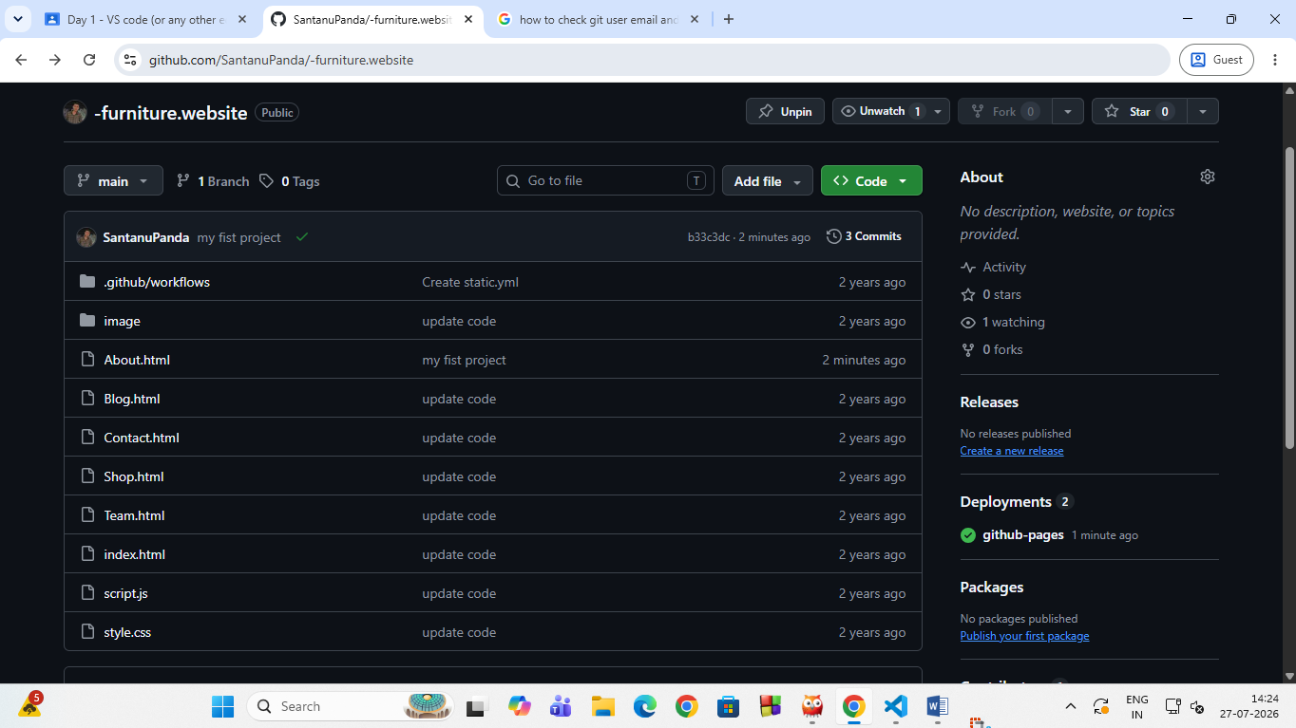
"Updated the About.html page for the “ -furniture.website” repository."
